**Why is it called Windows 10 and not Windows 9?**

By [Jamie Lendino](https://www.extremetech.com/author/jlendino) on July 28, 2015 at 10:16 am

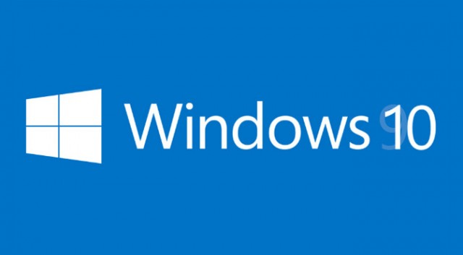Windows 10 is finally here — and it’s been a long and winding road. Let’s step back for a moment and address one of the most confusing things about the latest version of Windows. When Microsoft announced its newest operating system last year, the surprise was not that it was coming, but that Windows would be skipping version 9 and heading straight to 10. When asked about Windows 10’s name, Microsoft never really gave a clear answer. So why, exactly, did Windows 10 get the nod instead of 9?

[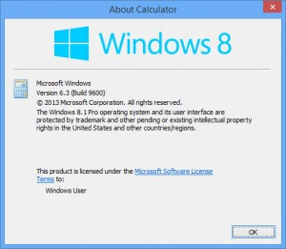](http://www.extremetech.com/wp-content/uploads/2014/10/windows-8-version-6.3.jpg)Version numbers, schmersion numbers

You may remember that between Windows 3 and Windows 7, Microsoft designated each version with a name instead of a number: 95, 98, NT, Me, 2000, Vista, and so on. When the company announced Windows 7, there was actually a similar amount of disbelief; after a series of named versions of Windows, it seemed odd to switch back to numbers.

Windows 8.1: Actually version 6.3, build 9600.

There’s also the fact that the name of each Windows release doesn’t actually match the *real* version number. For example, Windows 8.1 is actually version 6.3 of Windows. Windows 10 is version 6.4. The last time the release name actually matched the version number was the enterprise-focused Windows NT 4.0, which was released back in 1996. Windows 2000, which was called NT 5.0 during development, was actually version 5.0. Windows XP was version 5.1. Windows Vista was 6.0, Windows 7 was 6.1, Windows 8 was 6.2, and Windows 8.1 is version 6.3.

Windows RT, which only ran Metro apps, was a new and separate beast, but it still sat on top of the core Windows NT kernel. That one is dead now.

Modern versions of Windows are still based on the Vista kernel and code base — including Windows 10, which is actually Windows 6.4. There will be some confusion if (or when) we eventually reach internal version 7.0, but we’ll cross that bridge when we get there.

<https://www.extremetech.com/computing/191279-why-is-it-called-windows-10-not-windows-9>